If a product arrives damaged, is found to be faulty, or if you are unsure if the product is fit to use please call Pet Blood Bank UK within 24 hours of receipt or discovery to inform us of the issue. After notifying us, please complete and return this form electronically to customersupport@petbloodbanuk.org. If requested, please also return the product to us for investigation.

Please note, blood products must be returned using the original packaging and packaged in the same manner as received i.e. in a plastic zip lock bag to prevent leakage.

Account name:
Account number:
Address:

Postcode:
Phone:
Email:
Contact name and position:
Product name: | Unit ID number or batch/serial number:  Expiry date:
Date ordered: | Date received:
Date fault/damage identified:
Date notified Pet Blood Bank UK and contact name:
Brief description of issue/fault/damage:
Include acceptance and storage information and copy of temperature monitoring records (for blood products)

If blood product, please mark on images on page two where the fault/damage is located
Date product/blood bag and form sent to Pet Blood Bank:
Acceptance and storage information supplied: Yes/No
Temperature monitoring records supplied: Yes/No
Photos showing issue supplied: Yes/No
Signed:

Print name:

Please mark/circle on the diagram below areas where damage/fault has been identified

Blood bag front
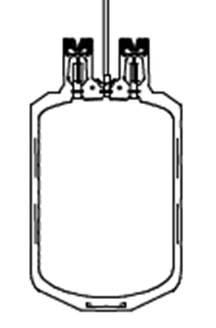

Blood bag back

This part of the form is to be completed by Pet Blood Bank UK staff
Date received by PBBUK: | Received by (insert staff name):
Date passed to Laboratory for assessment:
Product assessment (for damaged blood bags, please mark using red, areas of damage on diagram of form)

Manufacturer/supplier name:
Date notified (where applicable):
Communication/outcome:

Product outcome (include discard information where required):

Credit account holder: Yes/No Product replacement required: Yes/No
Other:
PBB staff name:
Date customer notified of decision: Method of notification: Telephone/email
Name of person notified:
Date Orderwise updated: Date credit note issued (if required):
Date replacement product dispatched (if required):
PBB staff name:
Non-conformance completed: Yes/No
Non-conformance reference number (if required):
Date closed:
Signed:
PBB Laboratory Manager:

